**Experiment : 4.1 Paul Thomas 30 S3 CSB**

**Program**

| public class trycatchfinally{  static void check(int age) throws IllegalAccessException{  System.out.println("Inside check function");  if(age < 18)  throw new IllegalAccessException("Demo");  }  public static void main(String []args){  try{  check(13);  }  catch(IllegalAccessException e){  System.out.println("Caught"+e);  }  finally{  System.out.println("Always Executed.");  }  }  } |
| --- |

Program

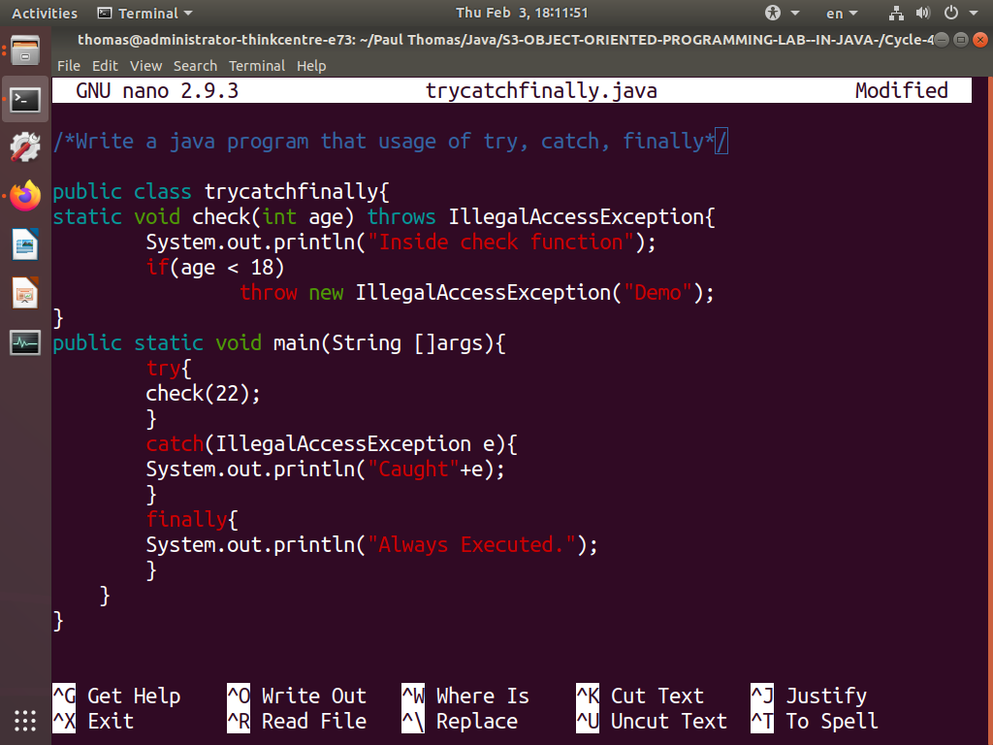

Output

